“Smart Water Level Monitoring
With TDS And SMS Alerts”-Known as “Aqua Sense”

INTRODUCTION

Aqua Sense is a comprehensive and integrated water-monitoring system designed to continuously track water levels, assess water quality, and provide instant notifications through SMS using the SIM800L GSM module.
The system brings together multiple sensors and components—such as an ultrasonic sensor for precise water-level measurement, a TDS (Total Dissolved Solids) sensor for evaluating water purity, an OLED display for real-time visual feedback, and a buzzer for immediate on-site alerts.
By combining sensor data with GSM-based communication, Aqua Sense ensures efficient, remote, and reliable monitoring.
This makes it ideal for tanks, reservoirs, agricultural setups, and any environment where maintaining water safety and availability is crucial.

List of components :

- Arduino UNO:
Microcontroller programming :Arduino boards can be programmed using the Arduino IDE, allowing users to write and upload code to control hardware. Sensor Integration: It can interface with various sensors (temperature, light, motion, etc.) to gather data from the environment. Actuator Control: Arduino can control actuators like motors, LEDs, and relays, enabling it to perform physical actions based on input.

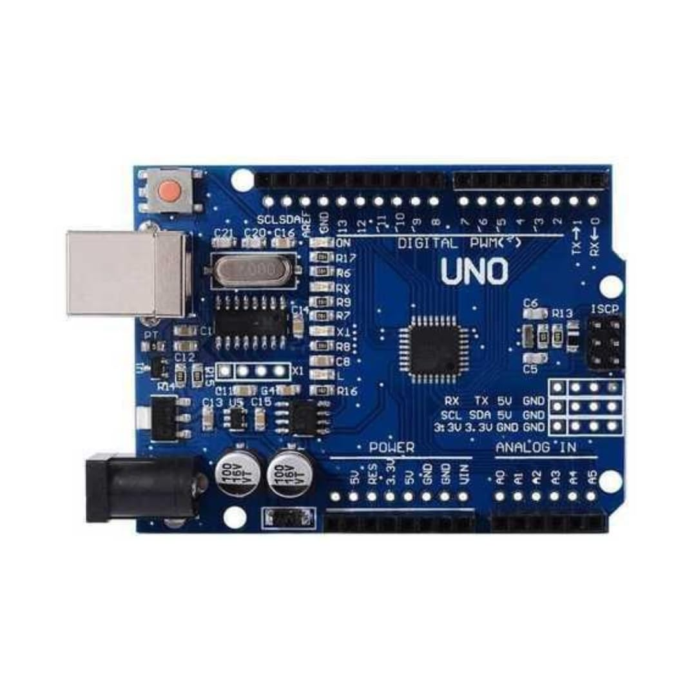

- Ultrasonic Sensor (HC-SR04)
The HC-SR04 ultrasonic sensor is a non-contact distance measurement module used widely in embedded systems, robotics, and fluid-level monitoring applications. In this project, it is employed to measure the water level inside a storage tank with high accuracy and reliability.
The sensor uses ultrasonic sound waves (40 kHz frequency) to calculate the distance between the sensor and the water surface.

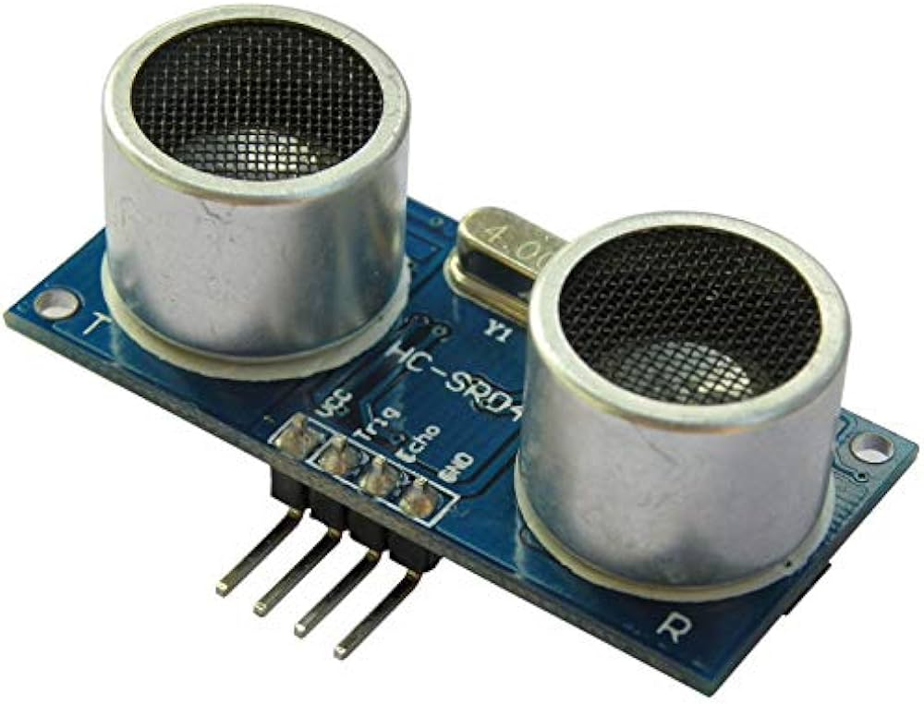
- TDS Sensor
A TDS sensor is used to measure the amount of dissolved solids present in water. These solids include minerals, salts, metals, and organic matter. In water-quality monitoring systems, TDS measurement is essential because it reflects the purity and potability of water.
In the Aqua Sense system, the TDS sensor provides continuous monitoring of water quality and triggers alerts if TDS levels exceed safe thresholds.

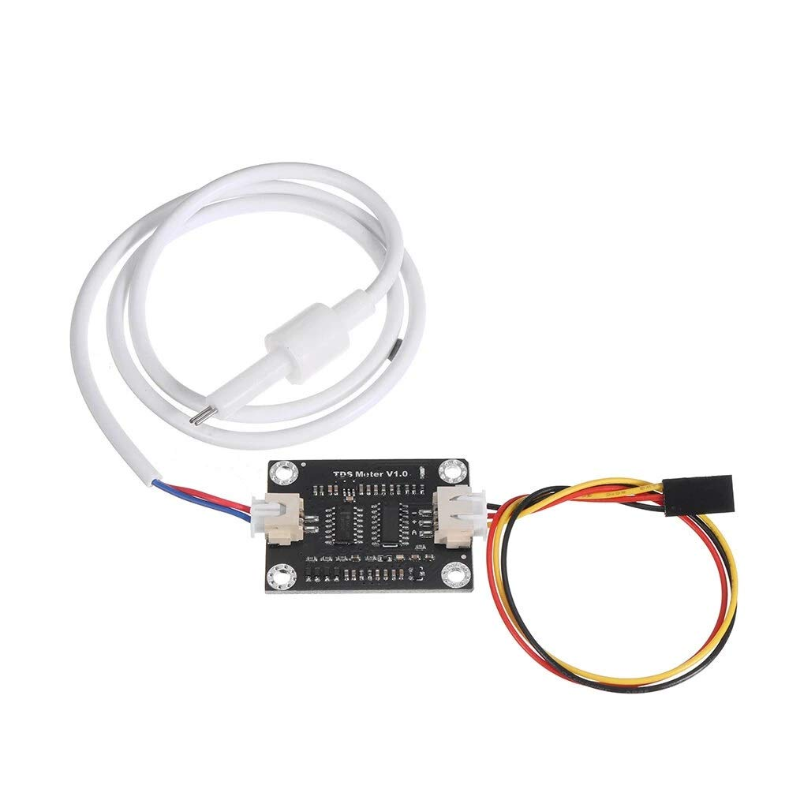

- OLED Display (SSD1306)

The SSD1306 OLED display is a compact, low-power graphical display used for real-time data visualization in embedded systems. In the Aqua Sense project, the OLED display is utilized to show the water level, liters remaining, TDS value, and water quality status, making the system user-friendly and highly informative.

The display uses organic LEDs, where each pixel emits its own light. This eliminates the need for a backlight and results in:
- High contrast
- Low power consumption
- Excellent visibility in low-light environments
The display communicates with the Arduino using the I2C protocol, enabling fast and efficient data transfer via only two wires: SDA and SCL.

In system, the OLED provides real-time visual feedback by displaying two different screens:
1. Water Level Screen:
- Percentage water level
- Remaining liters
- Vertical bar graph
- Low-level warning popup
2. TDS Screen:
- Current TDS value
- Water quality rating (Excellent / Good / Average / Poor)
- High TDS alert message
The display switches automatically every few seconds based on the timing logic in code.

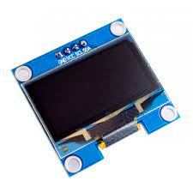
- Buzzer

A buzzer is an audio signaling device used to produce sound alerts in embedded systems. In the Aqua Sense project, the buzzer acts as an immediate local warning system, notifying users about low water levels or poor water quality without requiring visual monitoring or SMS alerts.

The buzzer provides audible alerts for the following conditions:
- Water Level Alert: Activates when the tank water level falls below 20%
- TDS Alert: Activates when TDS exceeds 500 ppm (poor water quality)
These sound alerts ensure the user receives instant warning, even if they are not looking at the OLED display or checking their phone for SMS notifications.

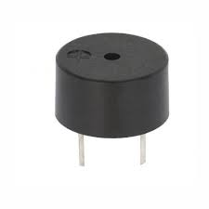
- SIM800L GSM Module
The SIM800L is a compact GSM/GPRS module that enables microcontrollers to communicate via cellular networks.
In the Aqua Sense project, the SIM800L is responsible for sending SMS alerts to the user whenever the water level becomes critically low or water quality falls below acceptable standards.
Its small form factor, low cost, and widespread compatibility make it ideal for IoT monitoring applications.

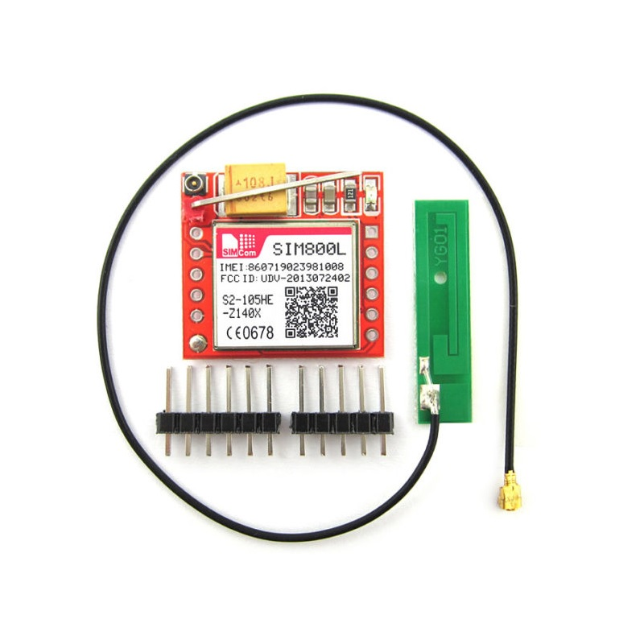
7.DC to DC Buck Converter (Step-Down Converter)

A DC-to-DC buck converter is an electronic power regulation circuit used to step down a higher DC voltage to a lower, stable DC output. In the Aqua Sense system, it is a critical component because the SIM800L GSM module requires a regulated 4.0V supply and cannot be powered directly from the Arduino’s 5V output.
Without a buck converter, the SIM800L may malfunction, reset, or get damaged due to voltage spikes.
The buck converter is essential because:
- SIM800L requires 4.0V, 2A peak, which Arduino cannot provide
- Ensures stable SMS operation without random resets
- Protects the GSM module from incorrect voltage supply
- Makes the power system safe, efficient, and reliable

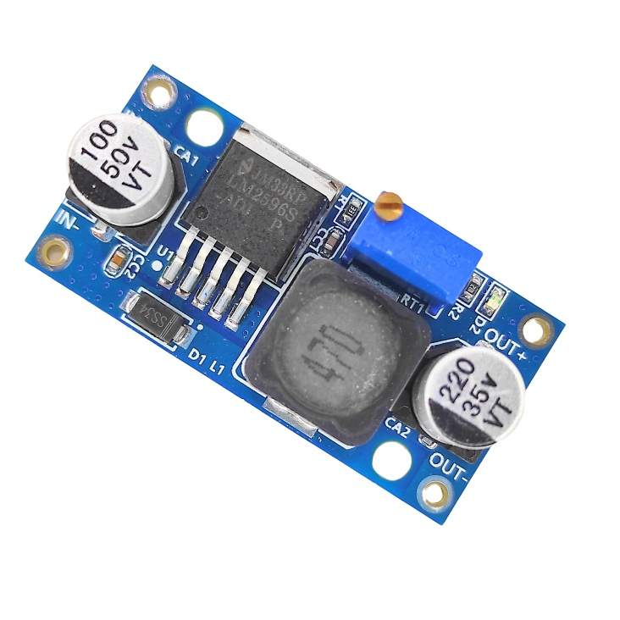

- Breadboard & Jumper Wires

A breadboard and jumper wires are essential prototyping tools used to build and test electronic circuits without soldering. In the Aqua Sense project, these components allow flexible interconnections between modules such as the Arduino UNO, ultrasonic sensor, TDS module, OLED display, SIM800L, buzzer, and buck converter.
Jumper wires are small insulated conductors used to make electrical connections on the breadboard.

Working :

The ultrasonic sensor continuously measures the water level inside the tank by calculating the distance between the sensor and the water surface. This measurement is converted into a percentage level and estimated volume. The TDS sensor monitors the quality of water by detecting the concentration of dissolved solids in parts per million (ppm). The OLED display provides real-time visual feedback of both water level and TDS readings, ensuring the user can quickly interpret system status.
For safety and immediate awareness, the buzzer activates to give an audible alert whenever the water level becomes critically low or the TDS value exceeds acceptable limits. Additionally, the SIM800L GSM module enhances remote monitoring by sending SMS notifications to the user. These messages are triggered automatically during important events such as tank full, low water level, or high TDS, enabling timely user action even when they are away from the system.

Circuit Diagram:

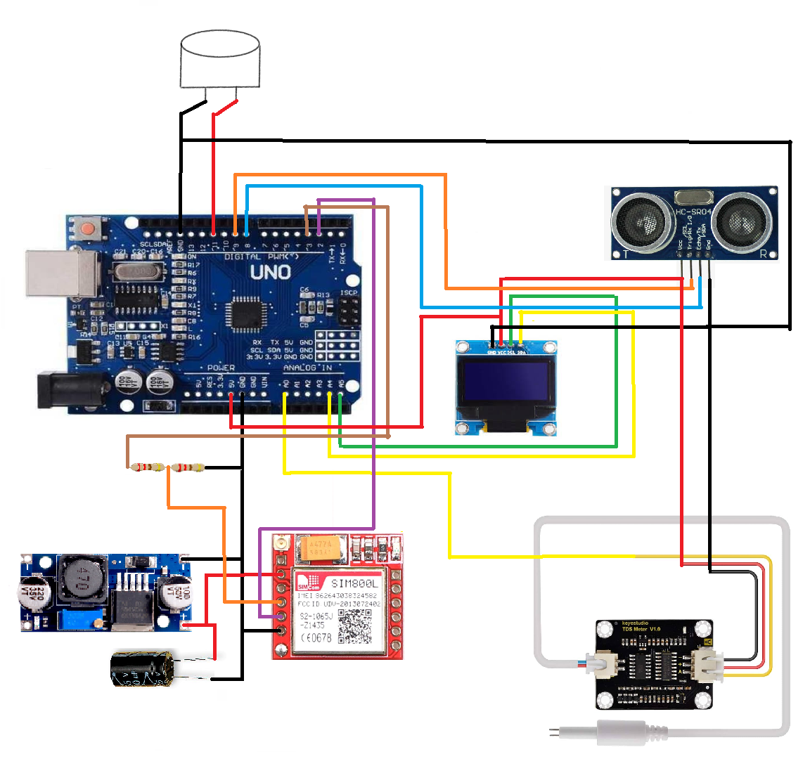

ADVANTAGES :

• Automated monitoring
• Prevents overflow
• Ensures water safety
• Remote SMS alerts
• Low-cost and scalable

FUTURE SCOPE :

• Add pH and turbidity sensors
• IoT cloud integration
• Automatic motor control
• Solar-powered version

CONCLUSION :

The Aqua Sense project provides an efficient smart water-monitoring solution suitable for homes and industries. It improves water management, reduces wastage, and ensures safe water quality

